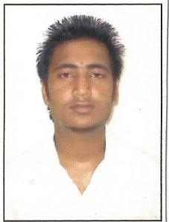
- NAME : Rohit Das

Photo

- FATHER’S NAME : Kishore Das

- PERMANENT ADDRESS : Paltan Bazar, P.O – Jalan Nagar, Dibrugarh, Assam

- MOBILE NO : 8876055116

- DATE OF BIRTH : 20-12-1996

- NATIONALITY : Indian

- RELIGION : Hinduism

- CASTE : Schedule Caste (SC)

- MARITAL STATUS : Unmarried

- SEX : Male

- QUALIFICATION : HSLC (X) passed – 51.33%
HS (XII) passed (Science Stream) – 56.4%
Now studying in B.SC 6th sem (Chemistry Honours)
- LANGUAGE KNOWN : Hindi, English & Assamese

DECLARATION:

I do here by declare that the above mentioned information’s are true to the best of my knowledge and belief.

Place: Dibrugarh
Date: Signature of the Applicant
Rohit Das

